- Project of Choice: CDMP

Personas:
- Journalists/Media
  - Journalists and media typically aim for the most accurate information to ensure that the information they are reporting is correct. If they are covering a story that involves the contribution records for every federal political entity, accessing them is nearly impossible.
  - They would need our product to easily access this information and ensure that there is no unusual donation activity occurring between ridings.
- Research Assistants/Students
  - Research assistants and students need large datasets for their projects, especially if the project involves studying campaign finance datasets or tracking hotspots for donors.
  - They would need our project to understand the variance in political party contributions. They may also need our product to understand where voting would most likely exist for a specific political party and study voting and political behaviour.
- Curious Public User/Civic Browser
  - They might want to know how much a political party has already received.
  - Satisfy personal curiosity about political donation patterns in their own riding or city with no prior knowledge of the dataset.
  - In case the user is interested in knowing how much their donation might matter towards an organization, i.e if the organization is already receiving a lot of funding.

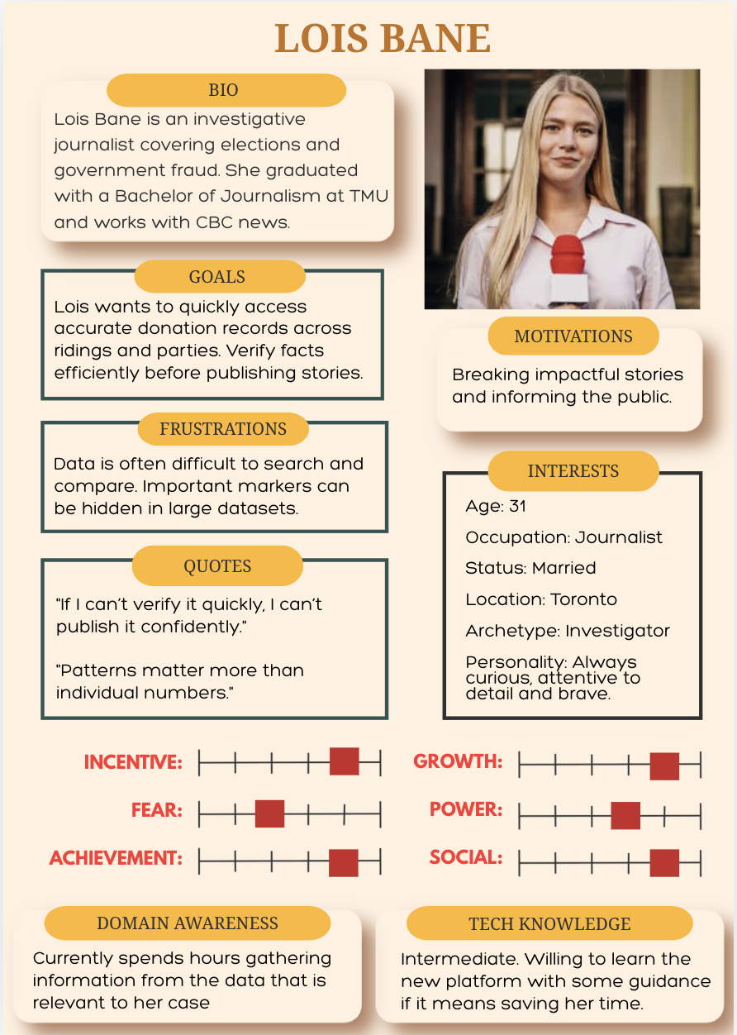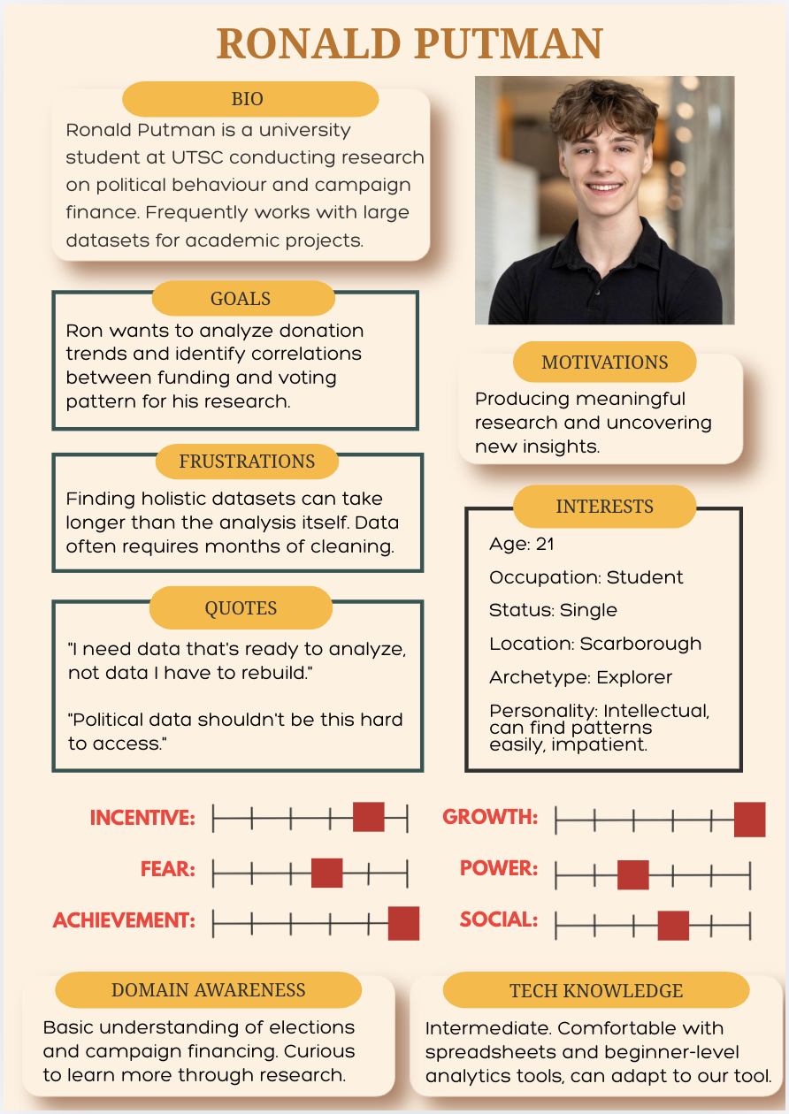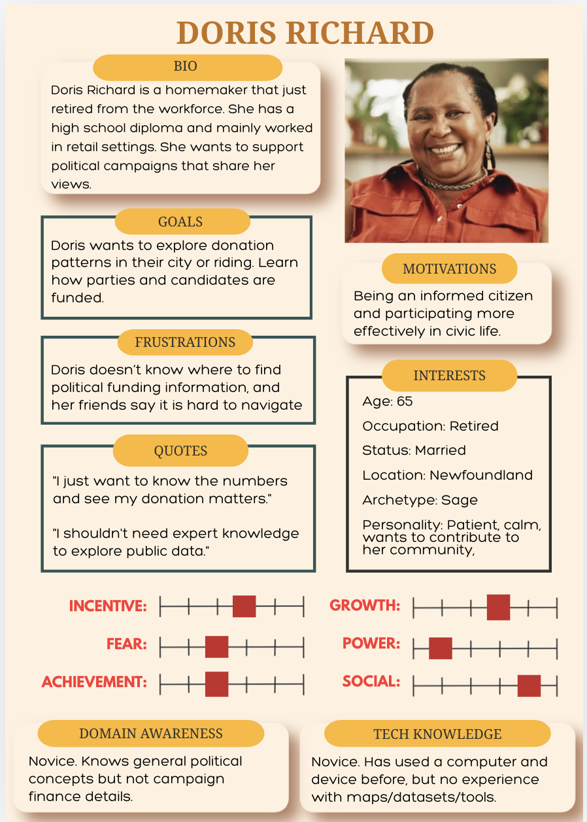

Use Case Diagram:
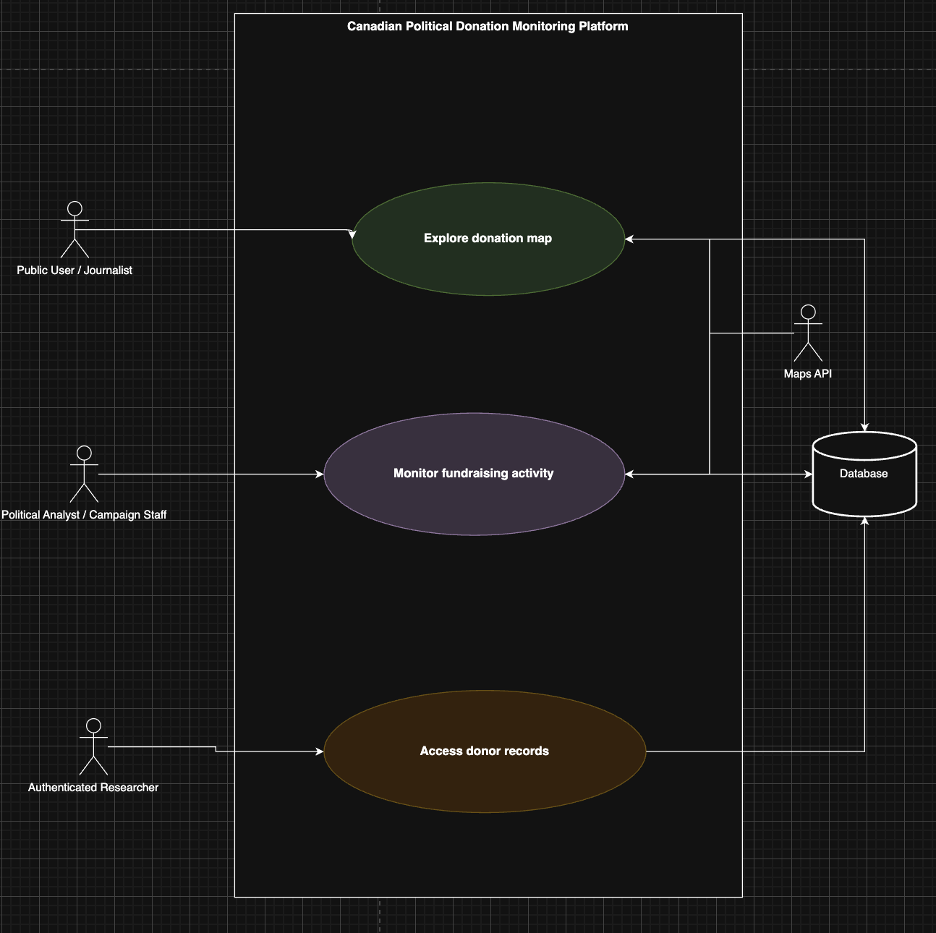

Use Case #1 — Explore Donation Map
Primary Actor: Public User
Goal: View political donation patterns geographically.
Description: The user selects a geographic level (province, riding, city) and views an interactive choropleth map displaying donation amounts.
User | App(System) | Map API | Database
1. Public user initiates by selecting the Map Exploration to view the map.
 | 2. System parses any filters that the public user applies (province, city, etc.).
 |  |  | 3. Database retrieves the relevant information based on the filter.
 |  | 4. The map shows the regions with shading based on the filters that were applied.
Alternative #1 — User navigates directly from a shared link
A1.1: User opens a bookmarked or shared URL with predefined filtering
 | Go to step 4
Alternative #2 — User selects a predefined view
A2.1: User chooses a preset analysis (e.g., "Federal Election 2025 Donations" or "Top Donating Ridings")
 | Go to step 4
Exception #1 — User selects filter with no data
 |  | E1.1: The map won’t have any shading due to a lack of data.

Use Case #2 — Monitor Competitor Fundraising Activity
Primary Actor: Political Party Analyst / Campaign Staff
Trigger: Election campaign period begins, or an analyst wants to investigate fundraising trends.
Goal: Compare donation activity between political parties across ridings and time periods.
Description: This use case allows a political analyst or campaign staff member to explore and compare fundraising activity across political organizations using an interactive system. The analyst can select a specific organization or geographic region and view total donations, regional contributions, and trends over time. The system also supports filtering by geography and time period, enabling flexible analysis of donation patterns.
User | App(System) | Map API | Database
1. Analyst initiates by selecting political organizations to compare
 | 2. Parses the user's political organization choice
 |  |  | 3. Database retrieves the relevant info of the political organizations
 |  | 4. The map shows the regions where those political organizations are.
 | 5. The app displays the regional and quantitative information about those political organizations and users can see and compare funding and other statistics. Moreover users are able to export CSV of the data if they so require. Also displays geographic information that is dynamic(users can click certain regions).
Alternative #1 — Analyst First clicks the map, then selects the specific parties
 |  | A1. 1 Map only shows the specified region
 | Go to step 5
Alternative #2 — Analyst searches for a political party
A2.1: Analyst searches in the system for a political party
 | A2.2: App parses the search response
 |  |  | Go to step 3
Exception #1 - User clicks an area of the map that does not contain any data
 | App produces a message saying region does not have data, and redirects the user to click another region

Use Case #3 — Access Individual-Level Donation Records
Primary Actor: Authenticated Research User
Goal: Access detailed donor-level political contribution data for academic research.
Description: A university-affiliated researcher logs into the research portal and searches, filters, and views individual donation records. The system enforces access controls and records all access activity for auditing purposes.
User | System | Database
1. Researcher logs into the research portal
 | 2. Verifies the researcher’s university affiliation and grants access
3. Researcher searches for individual donation records using filters (donor name, date, amount, party, etc.)
 |  | 4. Returns a list of matching individual donation records
 | 5. Displays detailed donor records to the researcher and logs the access activity
Alternative #1 — The researcher browses by searching for a specific donor name
 | A1.2: Verifies the researcher has permission to view the data
A1.3: The researcher enters a specific donor name into the search bar
 |  | A1.4: Returns all contribution records tied to that donor
 | A1.5: Displays relevant donor records and logs the donor-specific search and records viewed
Alternative #2 — Researcher exports records for offline analysis
A2.0: Researcher requests a data export of the current result set
 | A2.2: Checks that the researcher has export privileges
 |  | A2.4: Returns contribution data from the current result set
 | A2.?: Generates and delivers the export file to the researcher, then logs the export event
Exception #1 — Researcher enters invalid or out-of-range filter values
 | E1.4: The filter system flags the invalid input and shows an error message
E1.3: Researcher corrects the filter values and resubmits

UI Sketches:

Use Case #1 — Explore Donation Map
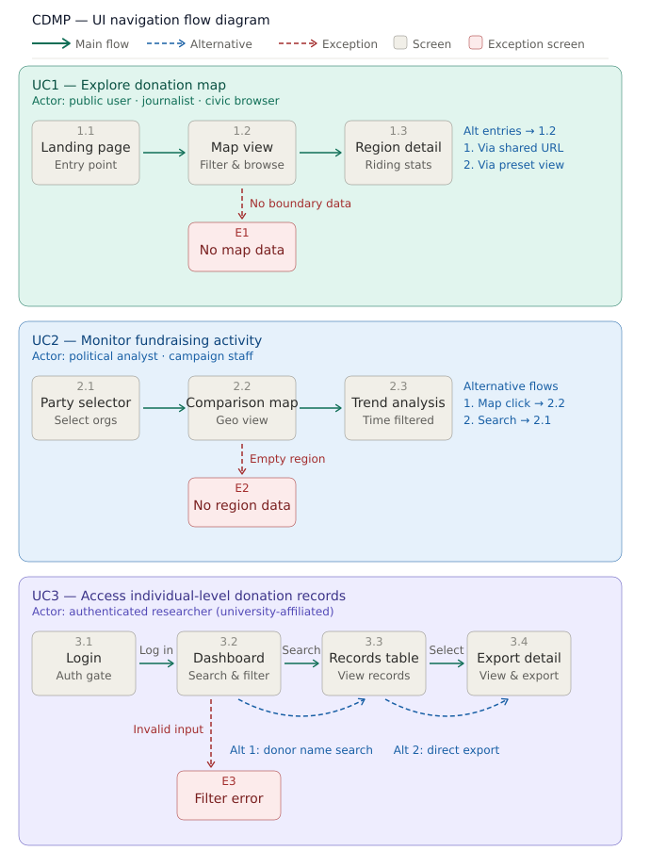

- Screen 1.1 - Landing Page
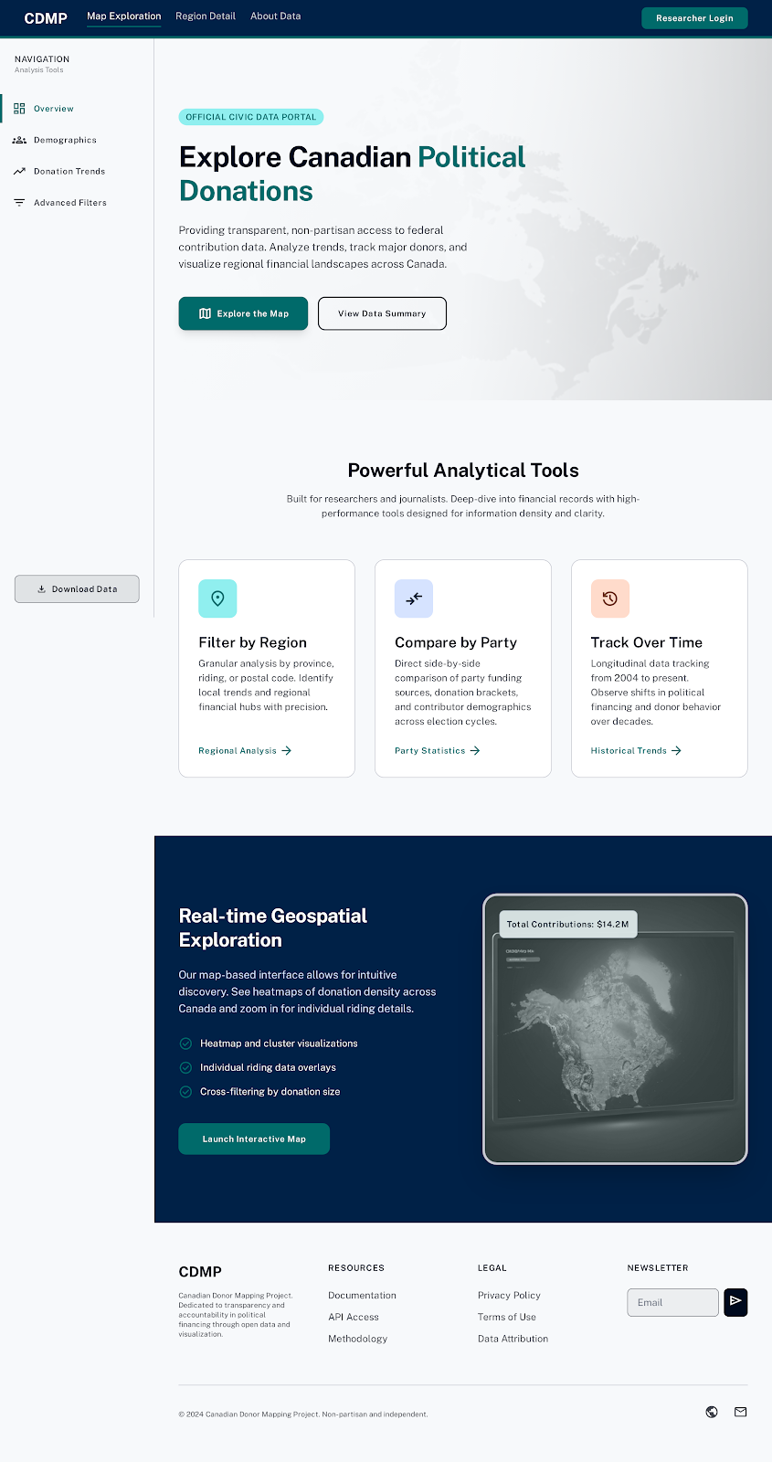

- Screen 1.2 - Map Exploration View
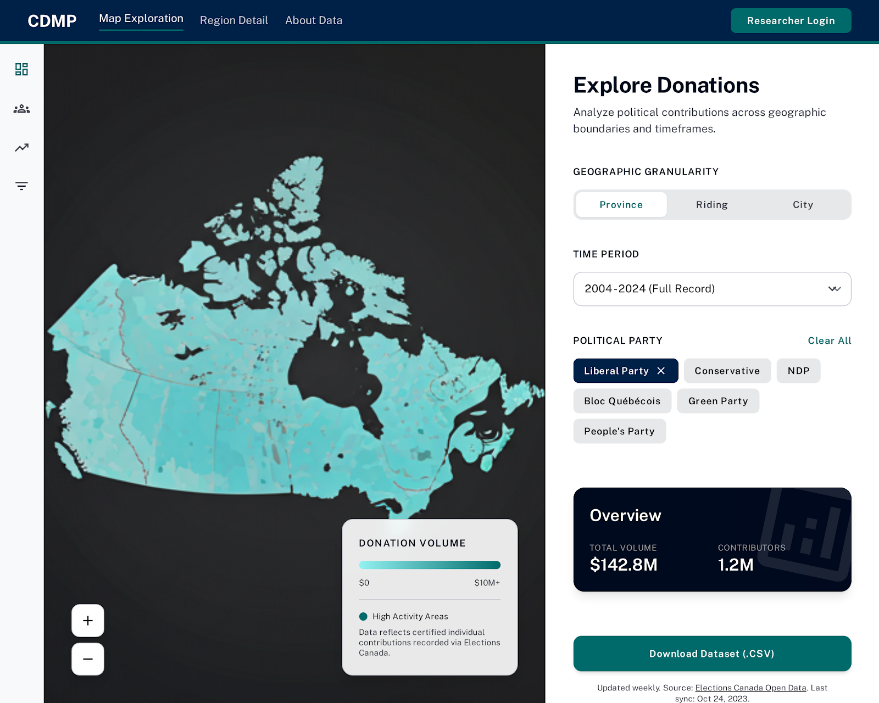

- Screen E1 (Exception) - No Map Data
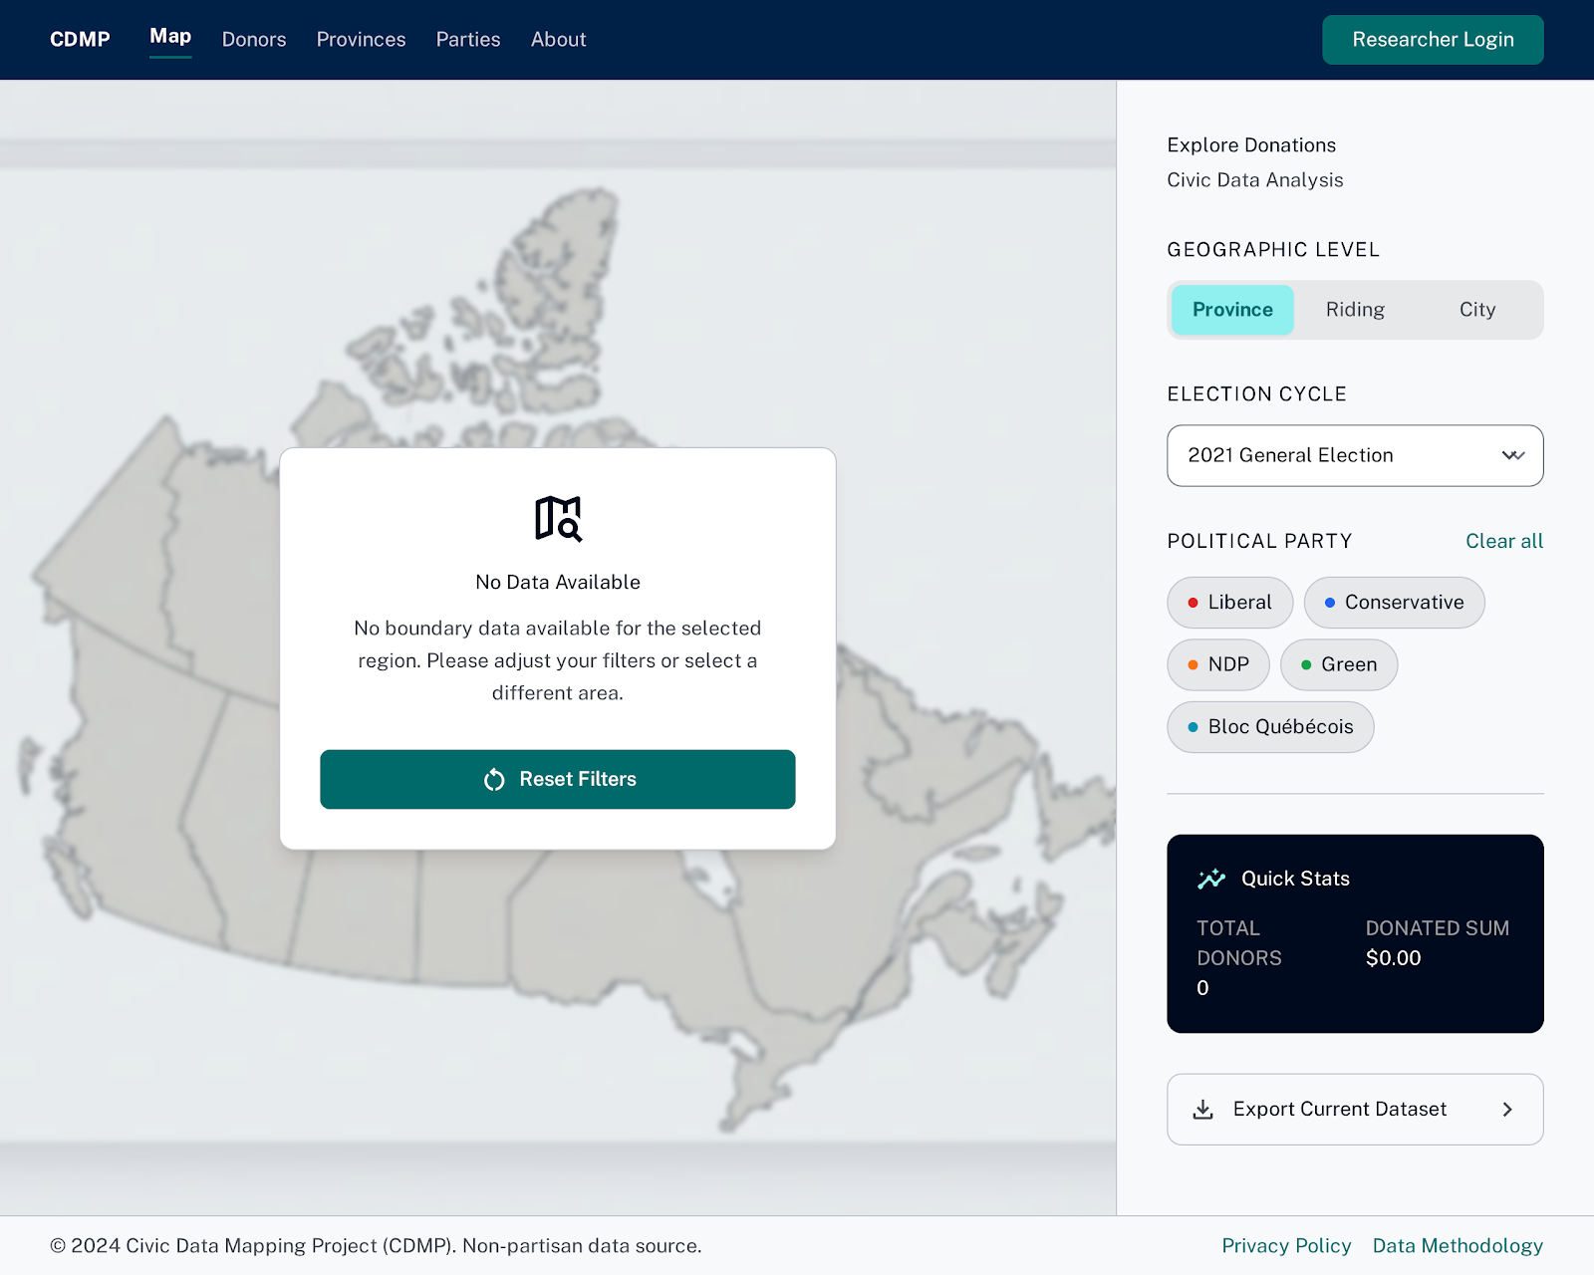

- Screen 1.3 - Region Detail Panel
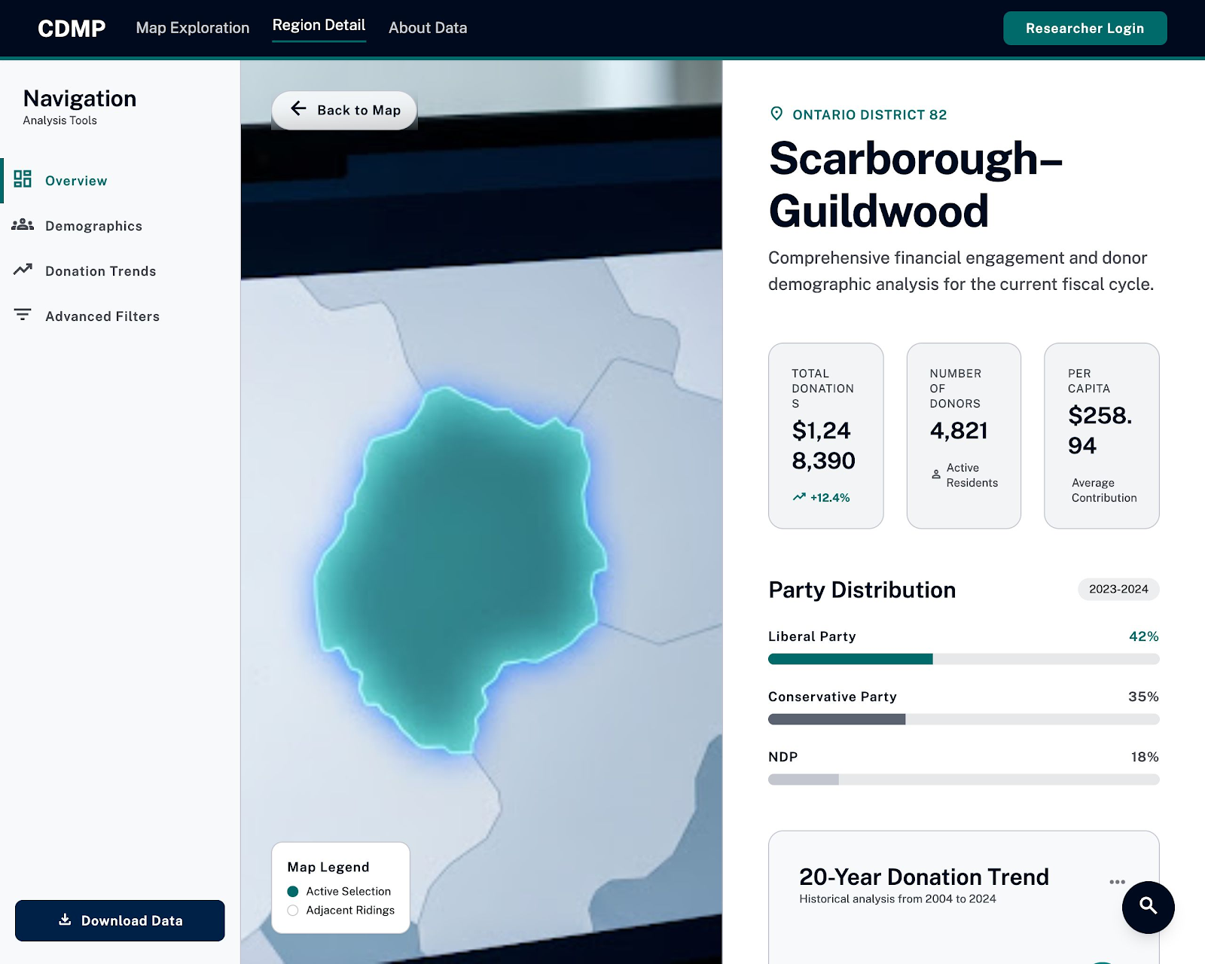

Use Case #2 — Monitor Competitor Fundraising Activity

- Screen 2.1 - Party/Organization Selector
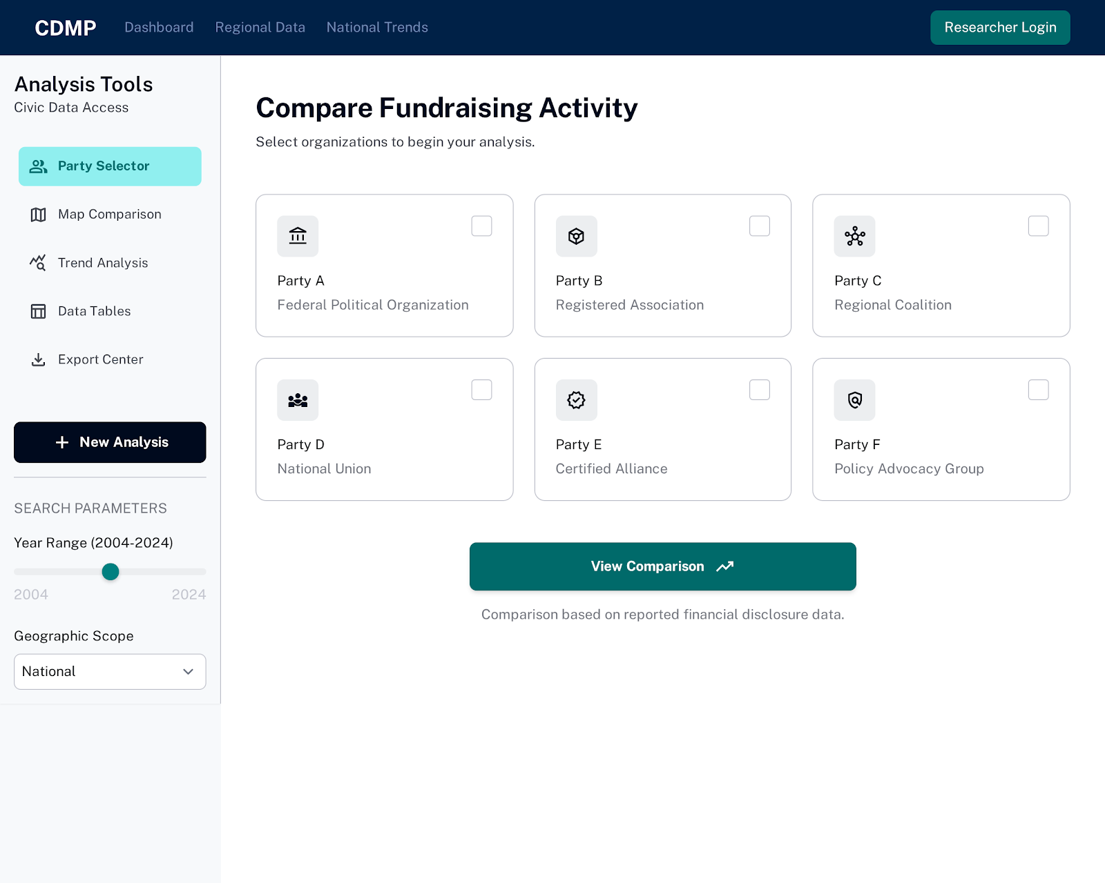

- Screen 2.2 - Fundraising Comparison Map
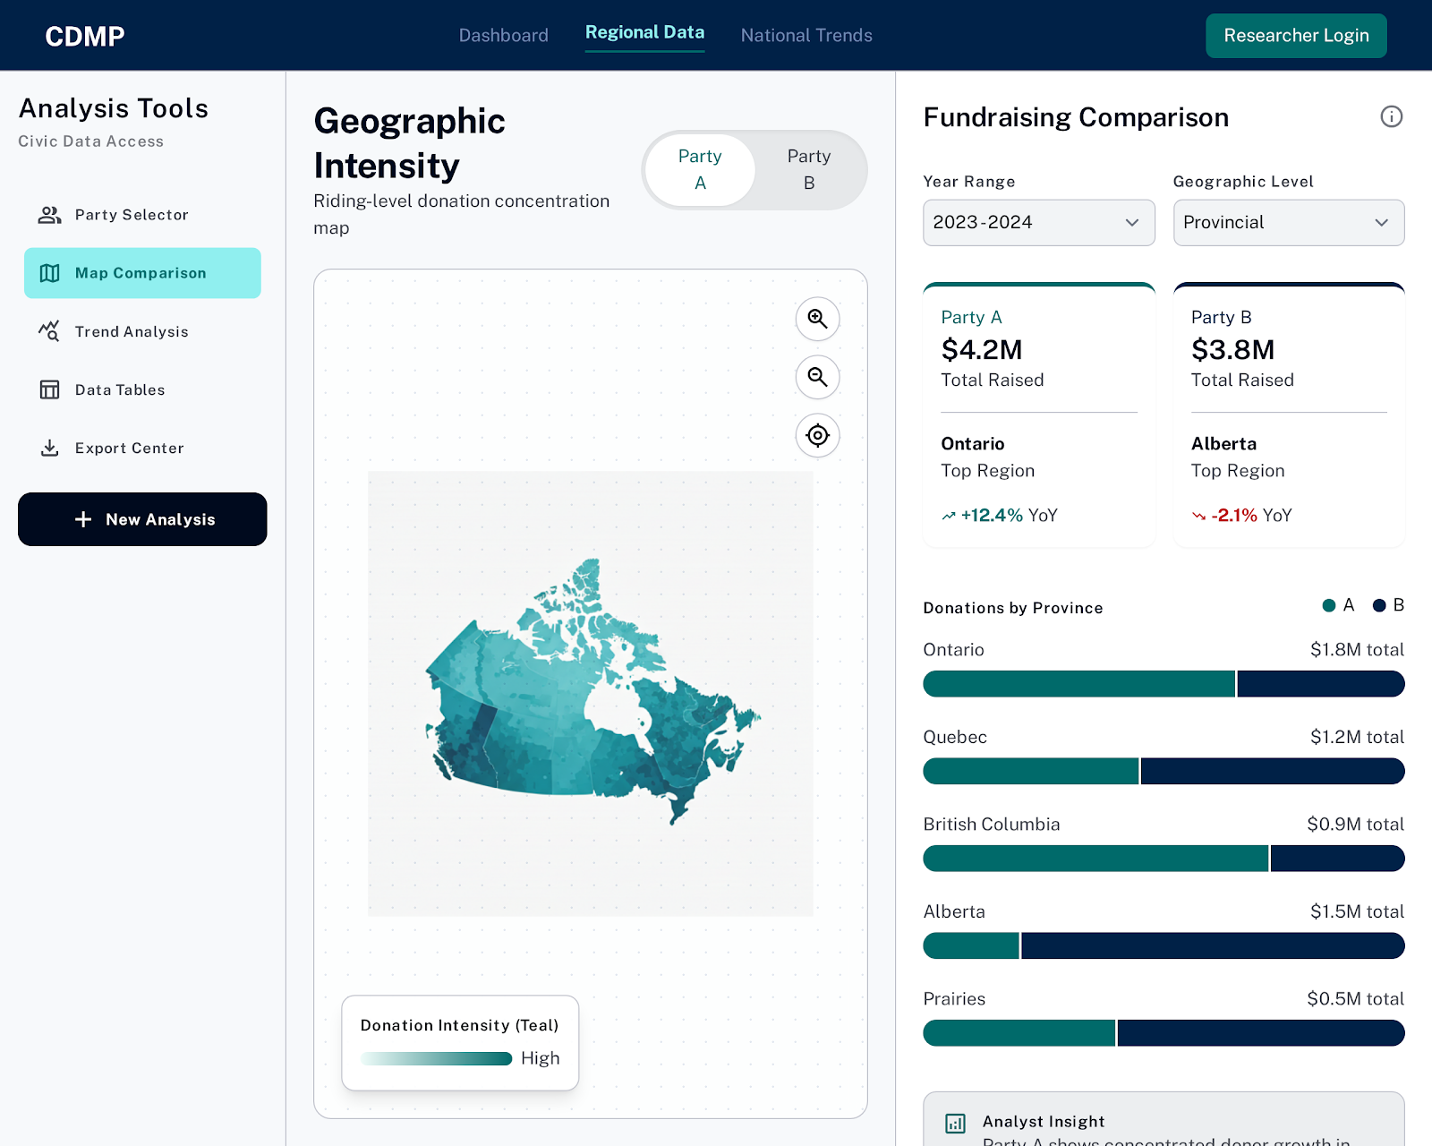

- Screen E2 (Exception) - No Region Data
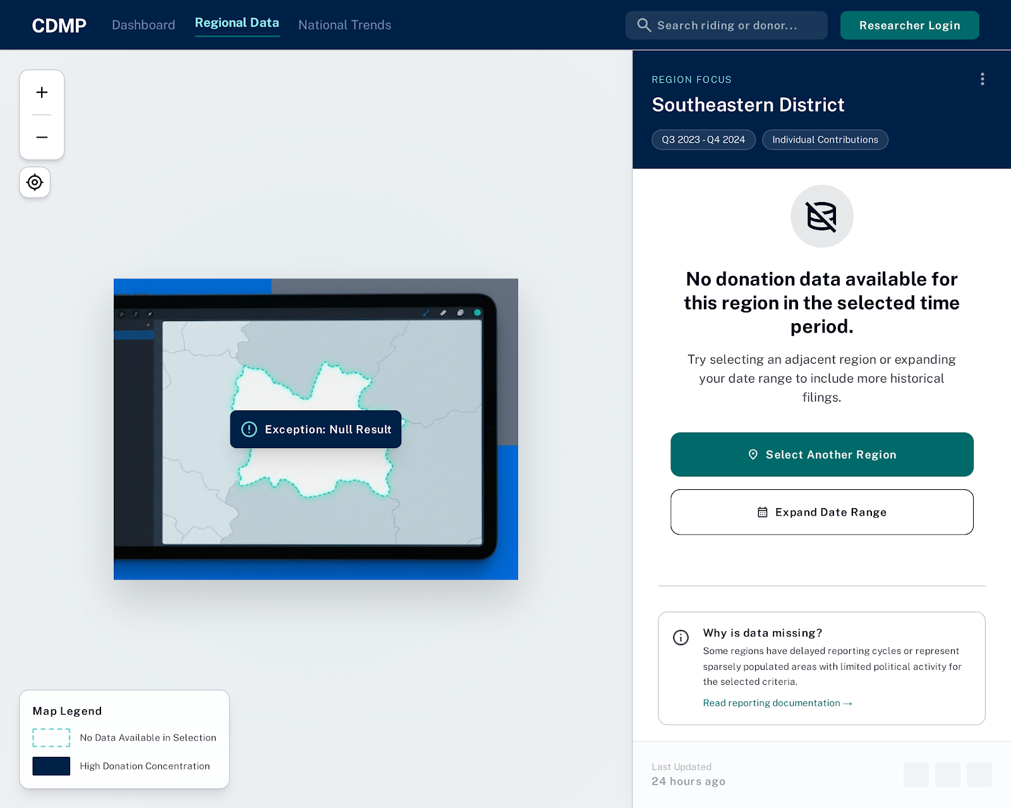

- Screen 2.3 - Time-Filtered Breakdown
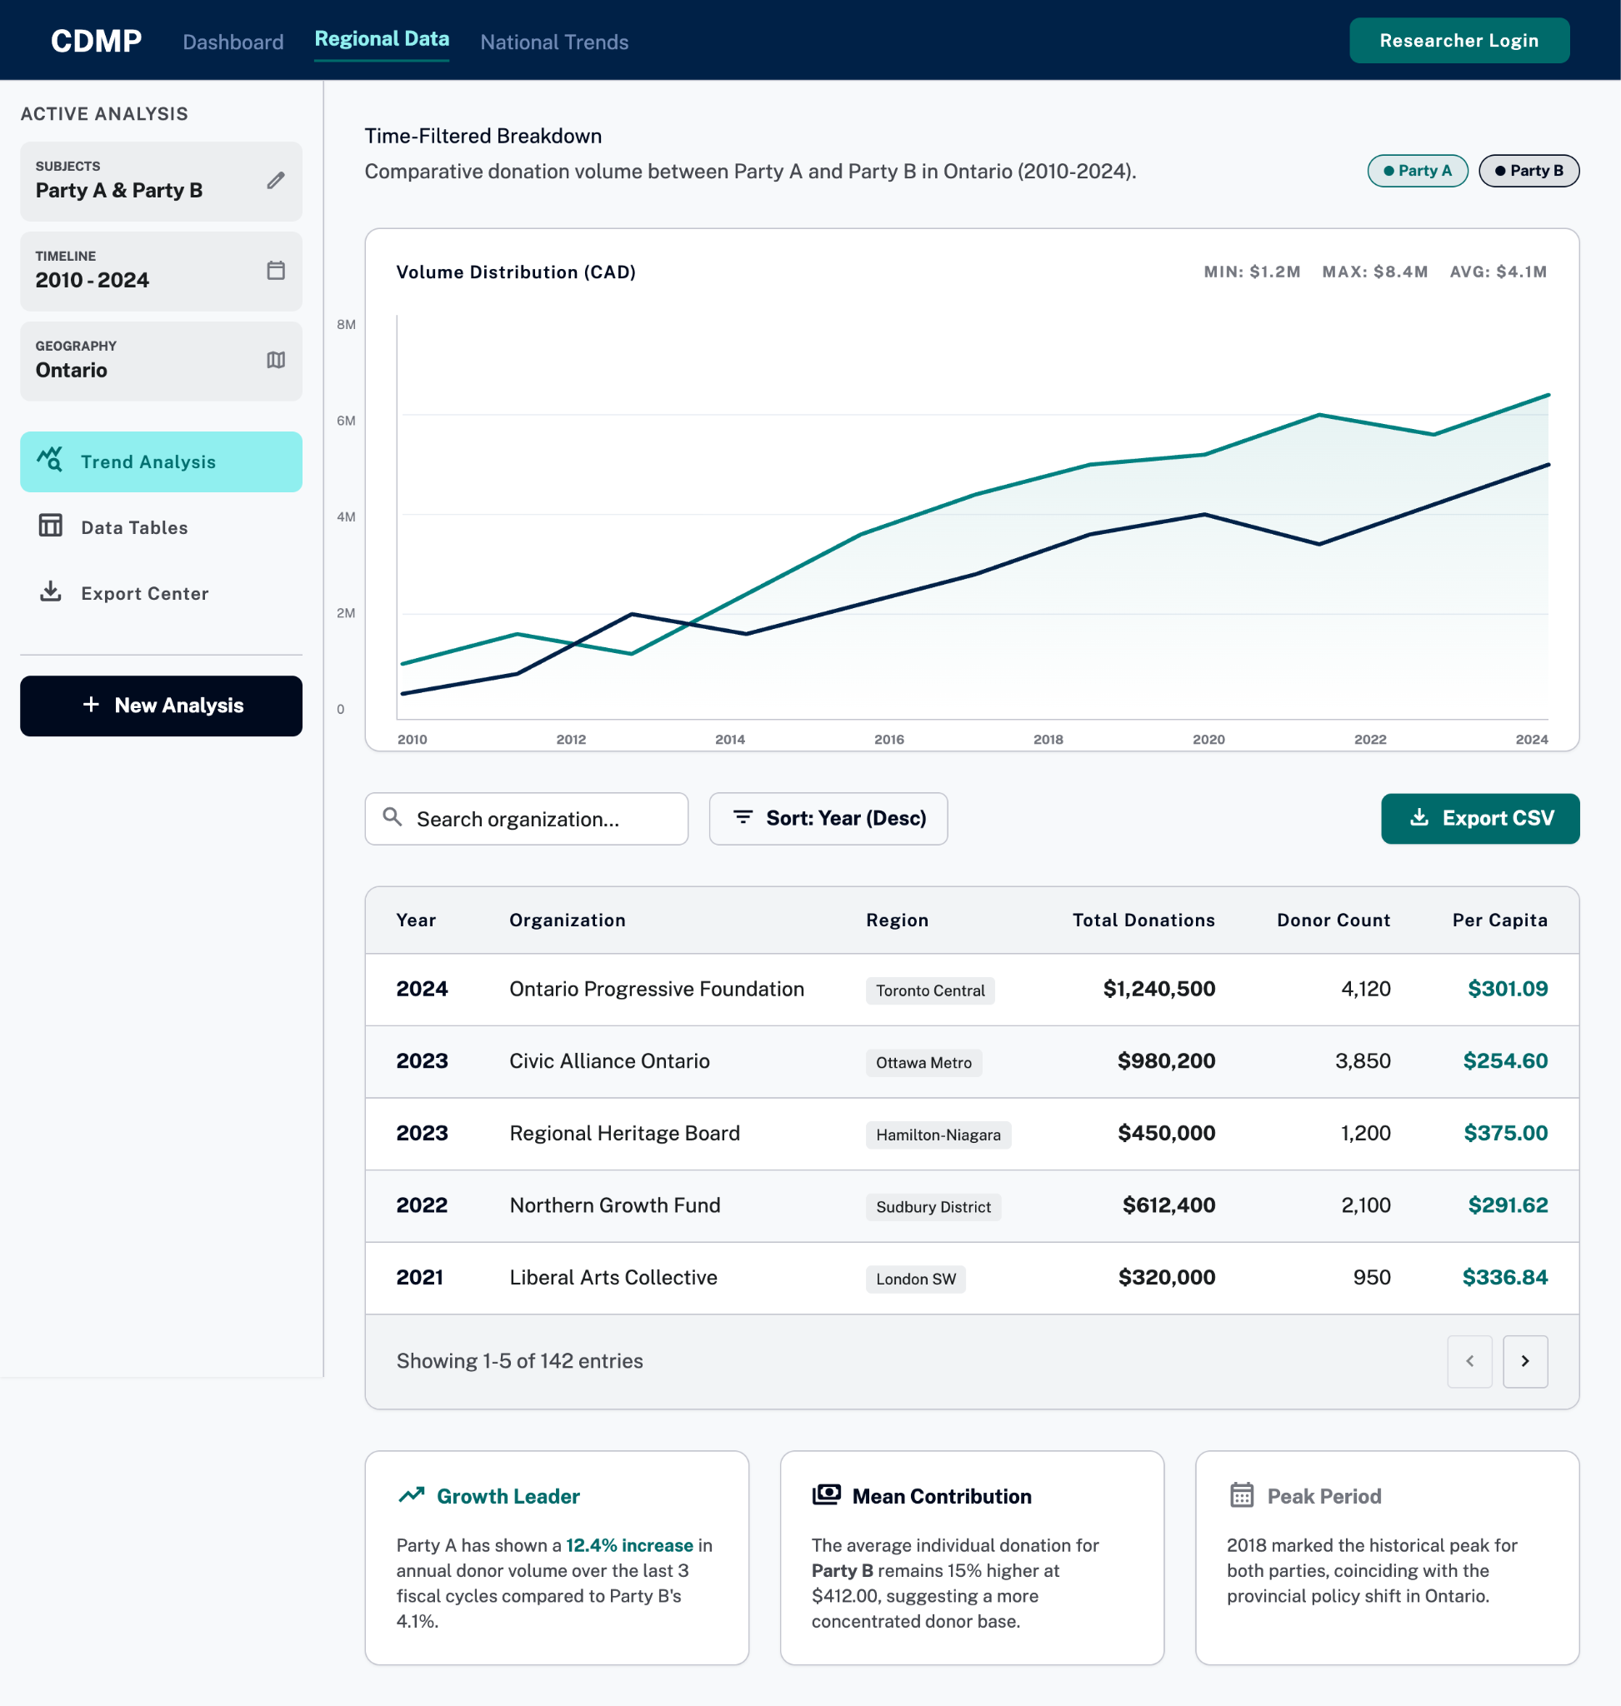

Use Case #3 — Access Individual-Level Donation Records

- Screen 3.1 - Login Screen
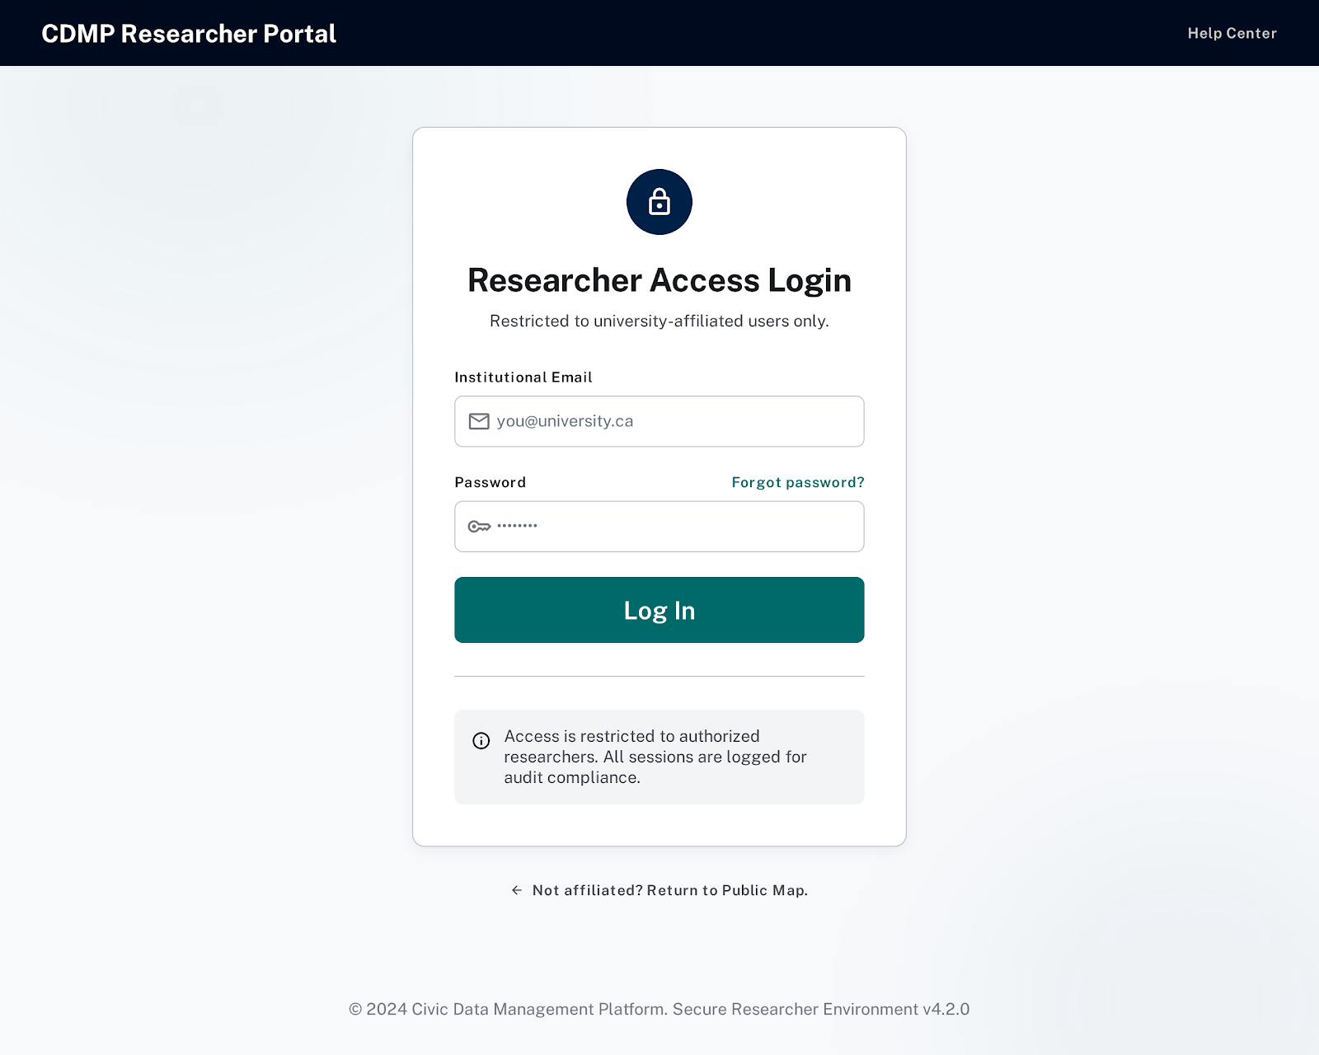

- Screen 3.2 - Authenticated Researcher Dashboard
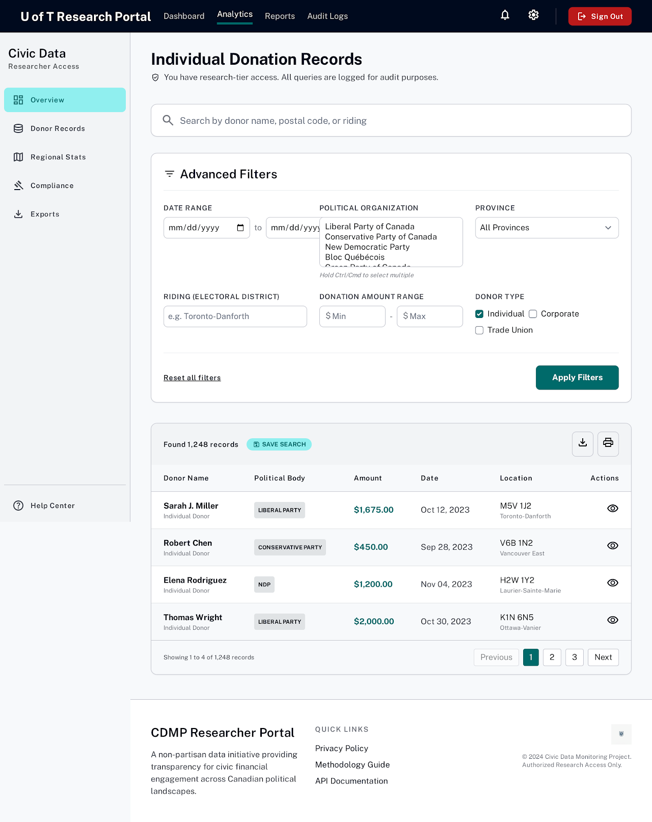

- Screen E3 (Exception) - Filter Error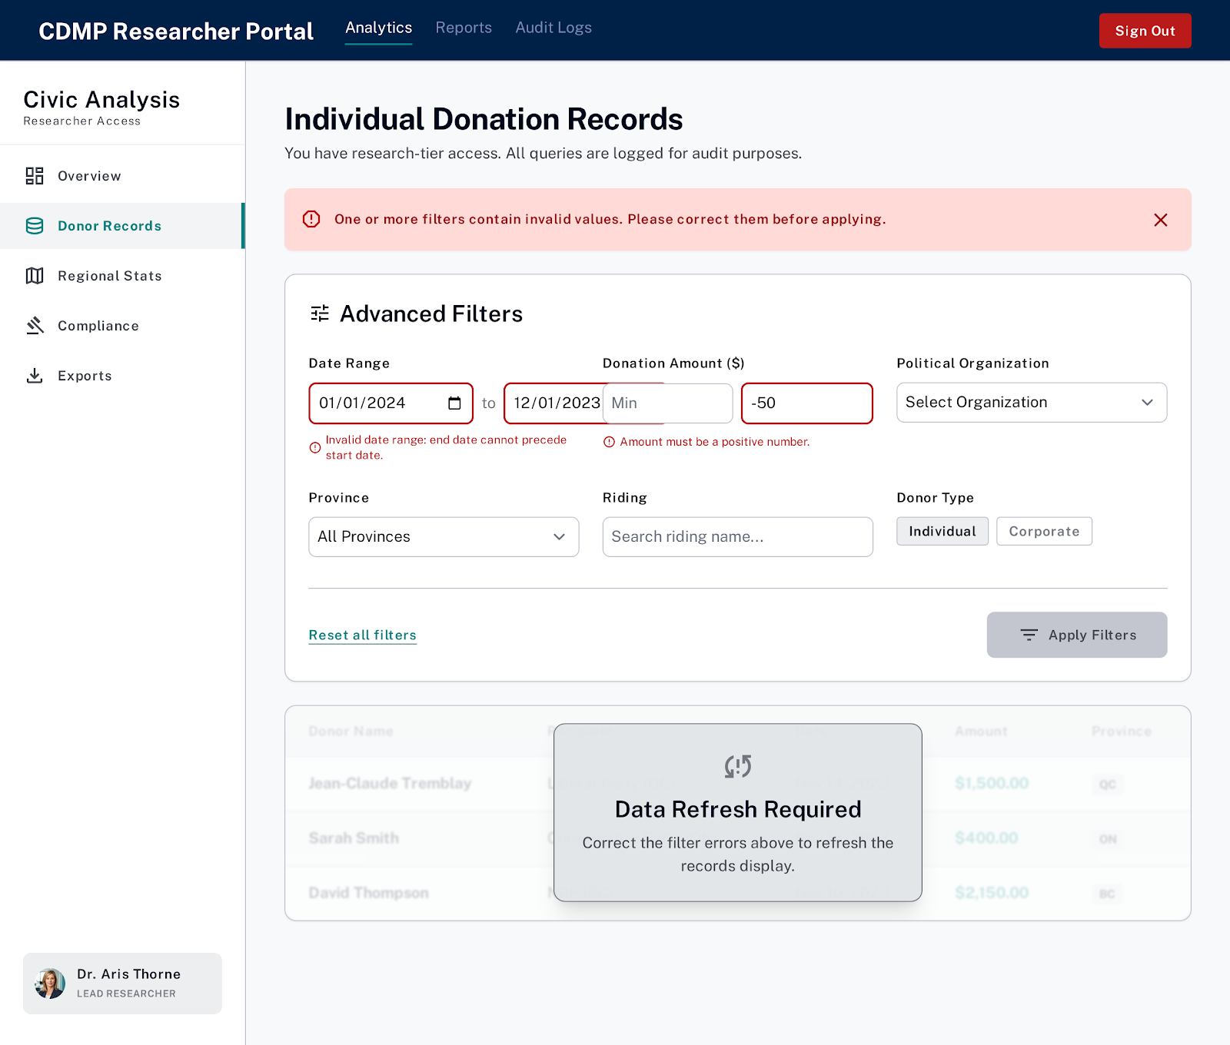

- Screen 3.3 - Individual Records Table
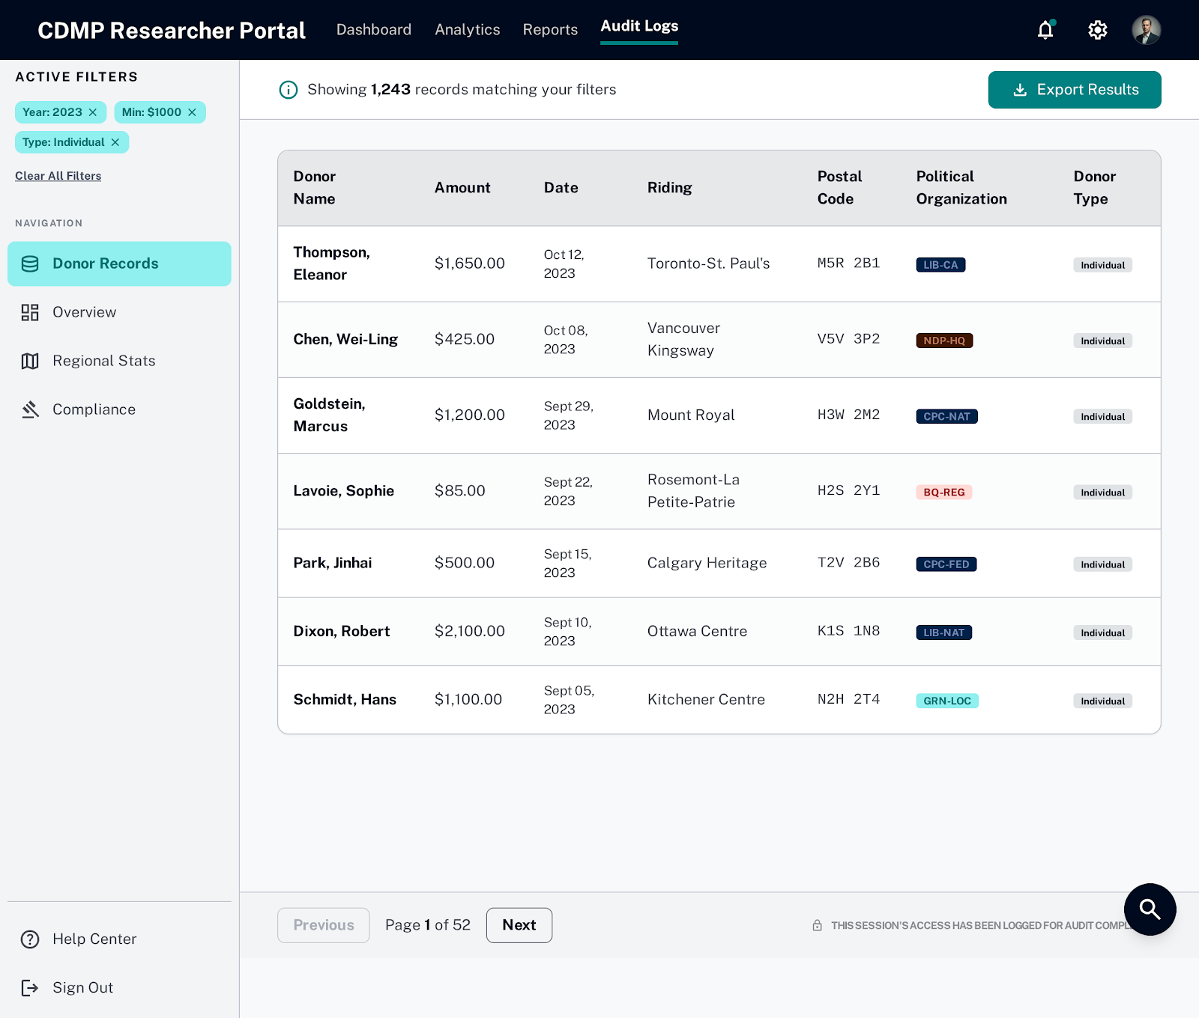

- Screen 3.4 - Record Detail / Export Confirmation
